HC 2 T2 U2
 | 題目 | 圖片
1 | I want some cake, please. | 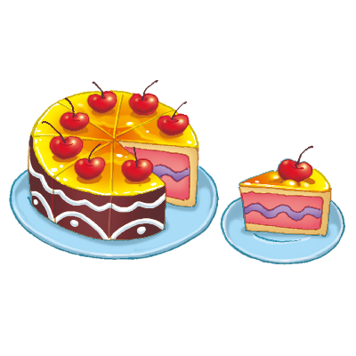
2 | I want some juice, please. | 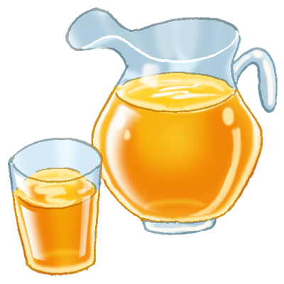
3 | I want some milk, please. | 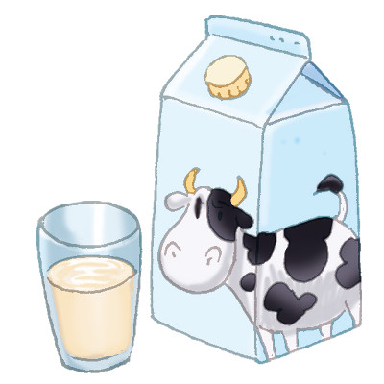
4 | I want some ice cream, please. | 